**Team members :- Boules Emad**

**Sohayla Hamed**

**Salma Hamed**

**19P9291**

**19P7343**

**19P8794**

Milestone -2

####

### #

#### ## #

###### # #

######### ######

# ##

++###+

######+

+######+

##+++##+

+#+ +##+

+##++###+

+#######+

+#######+

+##+###

++##+

+##+

###+

+###+

+##+

+##+

+##+

+##+

##+

+#+

+#+

++##+++

+######+

++#++ +##

+##+ ##

++#+ ##+

+#+ ##+

++ #+

+#+

+##+

##

+#+

+#+

+#+

+++ +#+

++########+

++#####++#####++

###+++ ++#++###+

+##+ ++### +++

+#########+

+++###++

# # ## #

# # # # #

# # # # #

# # ###### # #

# ## # #

# # # #

# #### #

#

# #

# ############### #

# # #### #

# # # #

# # # # #

# # # #

# # # #

# # # #

# # # #

# # # #

# # # #

# # # # #

# # # ###### # #

# # # # ## ### # #

# # # # ### # # #

# # # ## # # # #

# # # # # # ## # #

# # # # # # # #

# # # # # # # # #

# # # # ## # ##### # #

# # # # # ##

# # # # # # # #

# # # # # # # # ##

# # # # # # # # #

# # # # # # # #

# # # # # # # #

# # # # # # # #

# # # # ## # # # #

# # # # ## # # # #

# # # # # #

# # # # # #

# # # ######## # ## #

# # # # # #

# # # # # # #

# # ## ## # # #

# # ##### # # # #

# # # # # #

# # # # # #

# #### ## # # #

# ## ### # # #

# ###### # # #

# # # #

### # # # #

# # # # #

# # # # # #

# # # # #

# # ###### # # #

# ## #### # ##

# # # ###

## # # ##

## # # #

# # # ##

## # #

## # #

Contents

1. MLP ALGORITHM 3

1.1 STEPS…. 3

1.2 OUTPUT. 6

1.2.1 GridSearchCV 6

1.2.2 MLP PREDICTION EXAMPLE 7

1.3 VISUALISATION OF ACCURACY RANGE OF 1ST DATASET 7

1.4 VISUALISATION OF ACCURACY RANGE OF 2ND DATASET 8

2. SVM ALGORITHM 9

2.1 STEPS…. 9

2.2 OUTPUT OF 1ST DATASET 11

2.3 OUTPUT OF 2ND DATASET 11

2.4 VISUALISATION OF ACCURACY RANGE OF 1ST DATASET 12

2.5 VISUALISATION OF ACCURACY RANGE OF 2ND  DATASET 12

3. DECISION TREES 13

3.1 FACES.... 13

3.2 DIGITS… 15

# MLP ALGORITHM

## STEPS

1. **Import necessary libraries:**

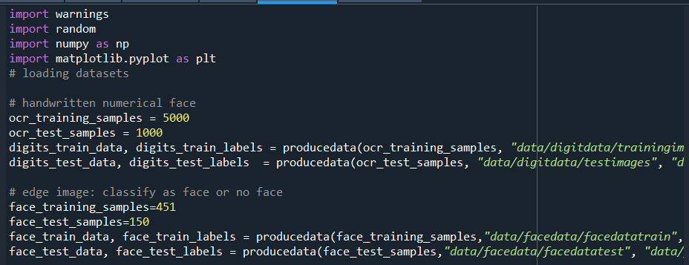

1. **Tune for best hyperparameters and visualize the scores**

Hyper-parameters are parameters that are not directly learnt within estimators. In scikit-learn they are passed as arguments to the constructor of the estimator classes. Typical examples include C, kernel and gamma for Support Vector Classifier.

The grid search provided by GridSearchCV exhaustively generates candidates from a grid of parameter values specified with the param_grid parameter.

Using GridSearchCV, we get the best accuracy and train the data using these hyperparameters. Then, we predict labels for the testing data and output the accuracy. We also visualize random hyperparameters combinations vs their score using matplotlib.

Note: The accuracy of the test data when using the optimal hyperparameters will be slightly less than the score using train data. This is because we use the train data to get the hyperparameters. Note also that the accuracy for face is less than digits all the time.

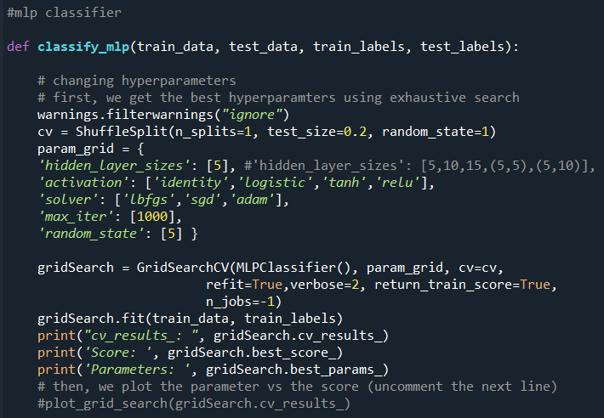

1. Train and test data using best hyperparameters

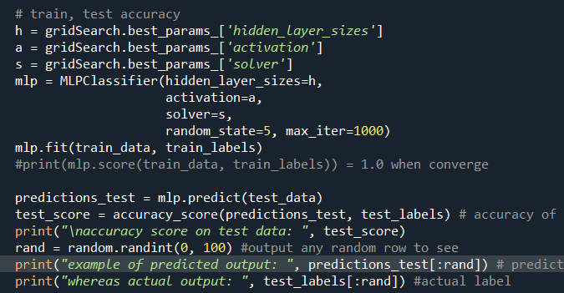

## 1.2 OUTPUT

### 1.2.1 GridSearchCV

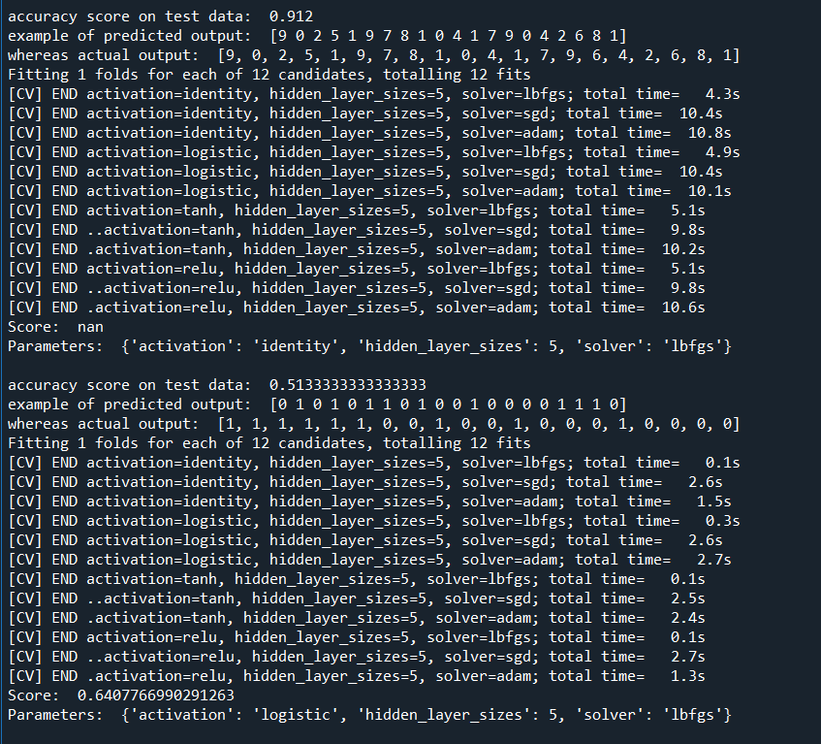

### 1.2.2 MLP PREDICTION EXAMPLE

## 1.3 VISUALISATION OF ACCURACY RANGE OF 1ST DATASET

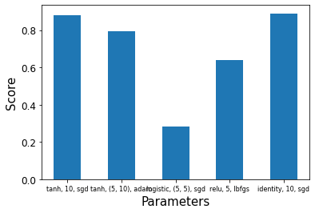

## 1.4 VISUALISATION OF ACCURACY RANGE OF 2ND DATASET

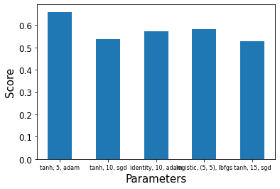

# SVM ALGORITHM

## STEPS

1. 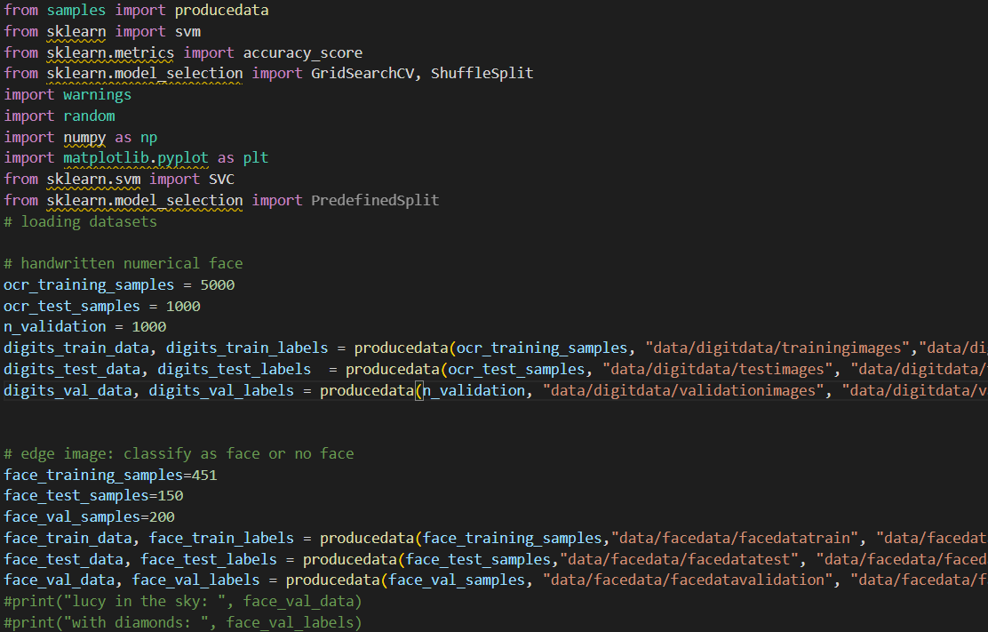**Import libraries and dataset**
2. **Classify SVM (main)**
3. **Changing hyperparameters**

Hyperparameters, C, kernel, and gamma were changed using GridSearchCV where we custom split the test and validation dataset with the ones provided in ‘data’ folder. Alternatively, we could use the ShuffleSplit defined in MLP. After plotting the score results, we use the best parameters to train and test the data, and finally we output an example prediction and label.

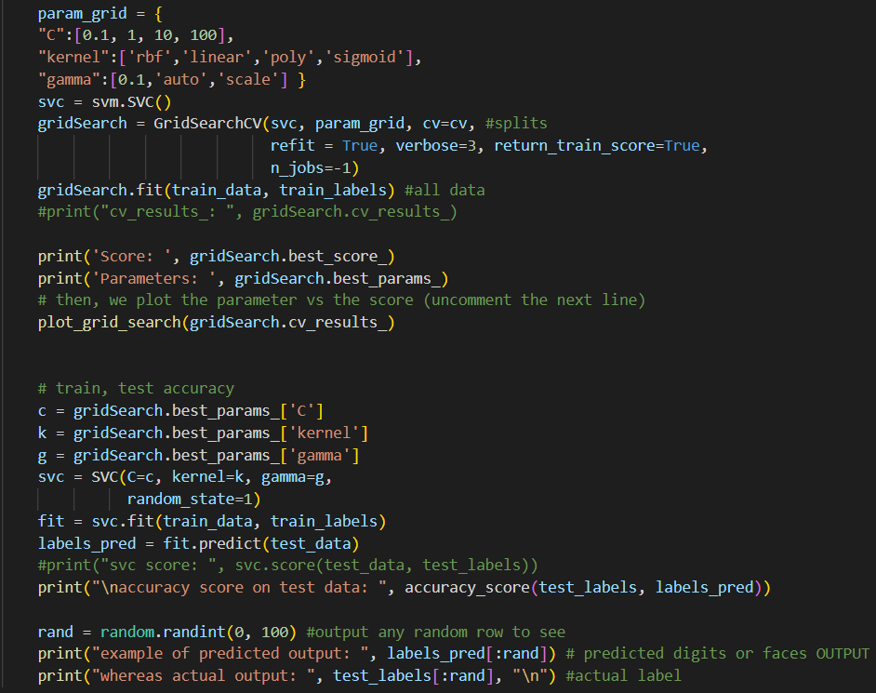

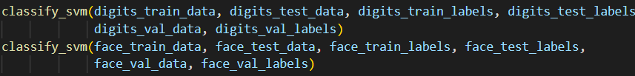

## OUTPUT OF 1ST DATASET

## OUTPUT OF 2ND DATASET

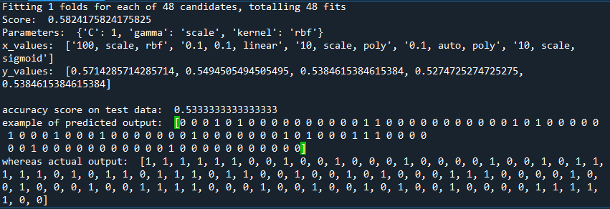

## 2.4 VISUALISATION OF ACCURACY RANGE OF 1ST DATASET

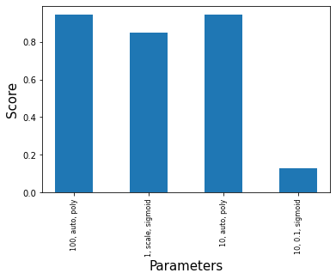

## 2.5 VISUALISATION OF ACCURACY RANGE OF 2ND DATASET

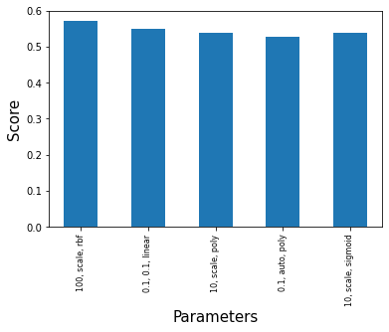

# DECISION TREES

## FACES

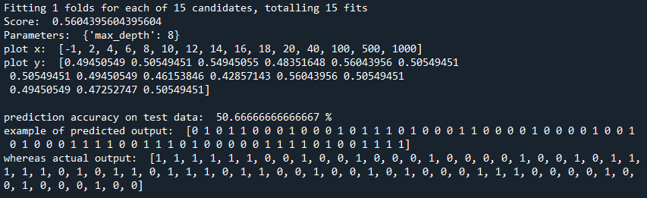

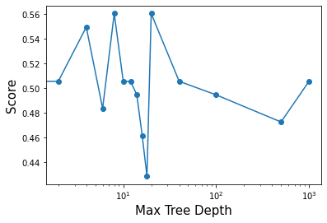

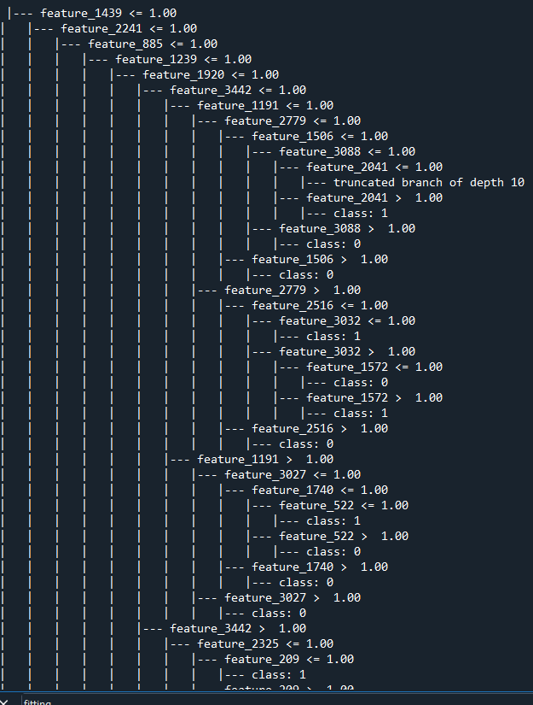

## DIGITS